Project Title: Digital Dice Circuit

Semester Project: Digital Logic Design

Course: BSCS-B

Teacher: Mam Warda Saeed

Submitted By:

# Muhammad Hamza Farooq (200901019)

# Muhammad Tayyab (200901018)

# Hamza Humayune (200901085)

**Chapter#01:**

**Introduction:**

Overview of Project:

In this project, we have designed the Digital Dice Circuit. Basically digital dice circuit is a type of modern dice. People play games like ludo using dice and they can also cheat while playing with dice but playing with digital dice no one can cheat as while playing with digital dice, people can press button and when release that button, digital dice will generate random number from 1 to 6. We are using 555 timer, 4017 and 7447 ICs and 7 segment display. By attaching the output of 555 timer IC with button and button with 4017 IC, by pressing the button, it will generate clock pulses which will give us 1 to 6, any random number on 7 segment display.

Block Diagram of Complete System (without using ICs, just use simple blocks):

**Use 555 timer IC to generate clock pulses.**

**Provide led blue and button on the output of 555 timer IC.**

**Also connect button to 4017 IC (CLK pin).**

**Connect small signal switching diode will outputs of 4017 IC.**

**Connect the output pins of 7447 IC with seven segment display.**

**Attach those diodes with the help of wires to 7447 IC and also with resistors.**

Clear Work Division:

Muhammad Hamza Farooq (200901019) will perform Multisim/Proteus Implementation.

Muhammad Tayyab (200901018) will make K.Maps and there implementation.

Hamza Humayune (200901085) will make logic Diagrams.

**Chapter#02:**

**Design:**

Problem Statement:

We have made digital dice because this will make none of the person while playing with dice can cheat. This digital dice will be used in ludo game. Sometimes players apply tricks on their opponents while playing the ludo game, like, while playing game, suppose one person is not active, one of them can change the position of number of dice and behave like nothing even happened. The players can also become tired as they frequently uses their hands to throw dice again and again and the dice can also result in breaking the glass present on covering ludo board. While taking all these problems into consideration, we have made the Digital Dice circuit.

Truth Table for 7-segment display:

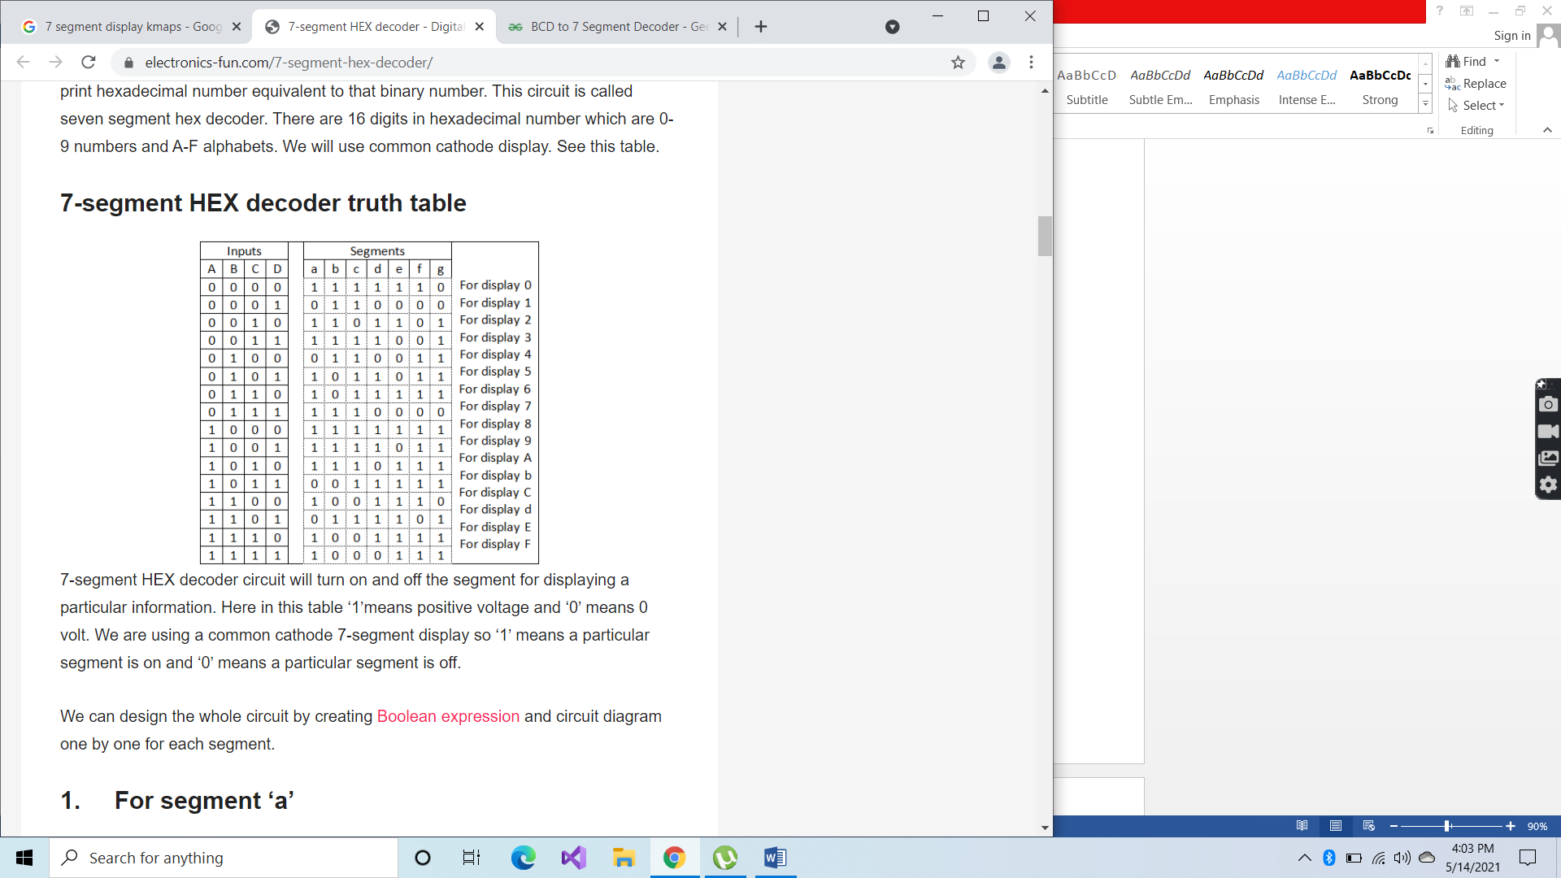

But we need to display from 1 to 6, so:

|  |  |  |  |  |  |  |  |  |  |  |  |
| --- | --- | --- | --- | --- | --- | --- | --- | --- | --- | --- | --- |
| A | B | C | D | a | b | c | d | e | f | g |  |
| 0 | 0 | 0 | 0 | X | X | X | X | X | X | X |  |
| 0 | 0 | 0 | 1 | 0 | 1 | 1 | 0 | 0 | 0 | 0 | Display 1 |
| 0 | 0 | 1 | 0 | 1 | 1 | 0 | 1 | 1 | 0 | 1 | Display 2 |
| 0 | 0 | 1 | 1 | 1 | 1 | 1 | 1 | 0 | 0 | 1 | Display 3 |
| 0 | 1 | 0 | 0 | 0 | 1 | 1 | 0 | 0 | 1 | 1 | Display 4 |
| 0 | 1 | 0 | 1 | 1 | 0 | 1 | 1 | 0 | 1 | 1 | Display 5 |
| 0 | 1 | 1 | 0 | 1 | 0 | 1 | 1 | 1 | 1 | 1 | Display 6 |
| 0 | 1 | 1 | 1 | X | X | X | X | X | X | X |  |
| 1 | 0 | 0 | 0 | X | X | X | X | X | X | X |  |
| 1 | 0 | 0 | 1 | X | X | X | X | X | X | X |  |
| 1 | 0 | 1 | 0 | X | X | X | X | X | X | X |  |
| 1 | 0 | 1 | 1 | X | X | X | X | X | X | X |  |
| 1 | 1 | 0 | 0 | X | X | X | X | X | X | X |  |
| 1 | 1 | 0 | 1 | X | X | X | X | X | X | X |  |
| 1 | 1 | 1 | 0 | X | X | X | X | X | X | X |  |
| 1 | 1 | 1 | 1 | X | X | X | X | X | X | X |  |

K-Maps and its implementation:

For a:

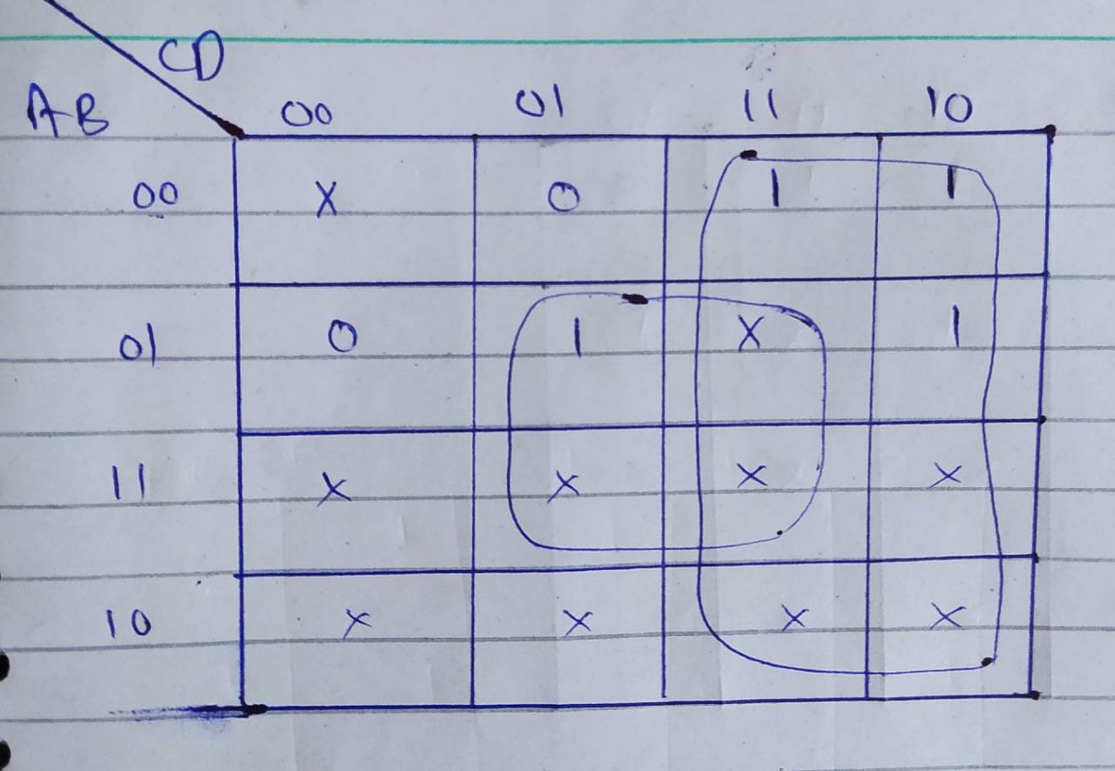

Implementation:

1. m3+m2+m7+m6+m15+m14+m11+m10

= C

1. m13+m15+m7+m5

= BD

So,

a = C+BD

Logic Diagram:

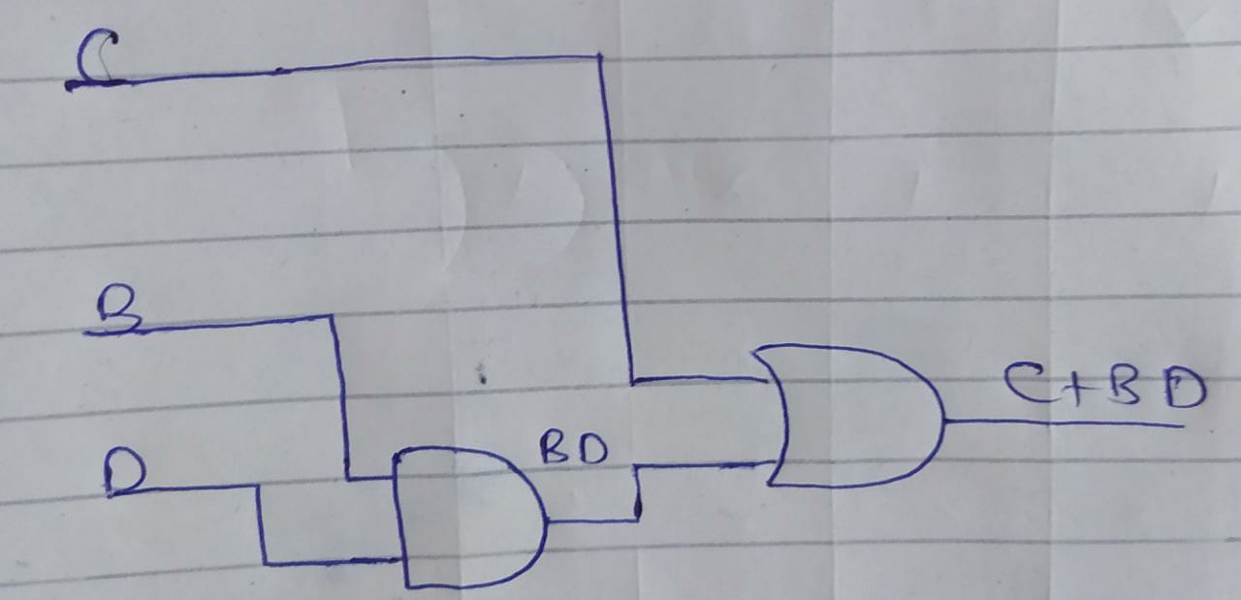

For b:

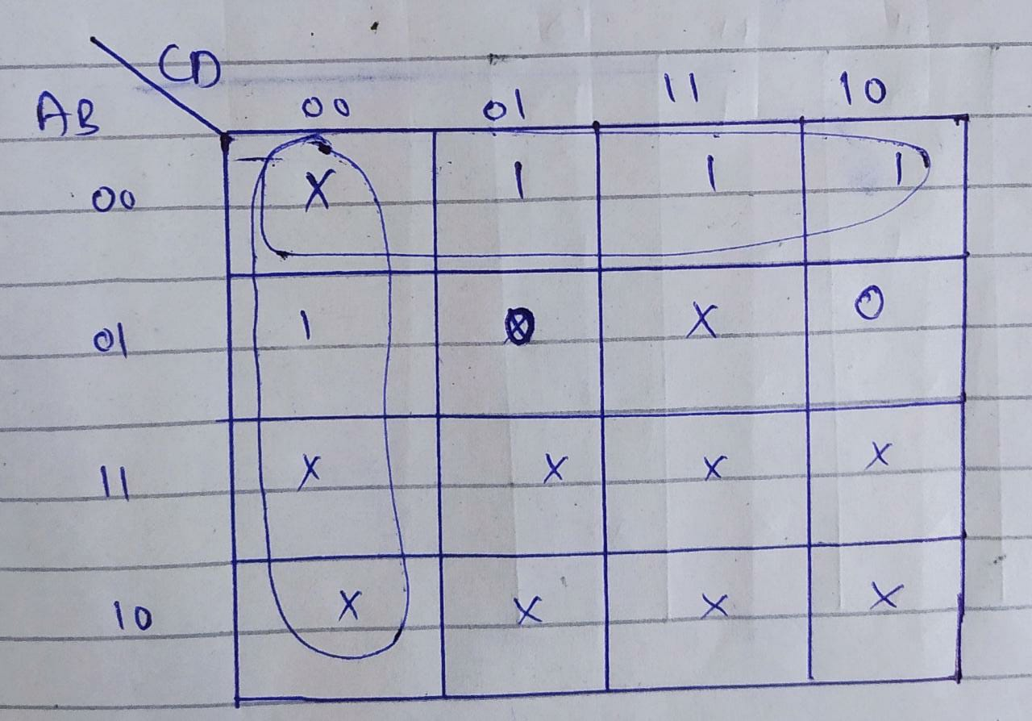

Implementation:

1. m0+m1+m3+m2

=A’B’

1. m0+m4+m12+m8

=C’D’

So,

b= A’B’+C’D’

Logic Diagram:

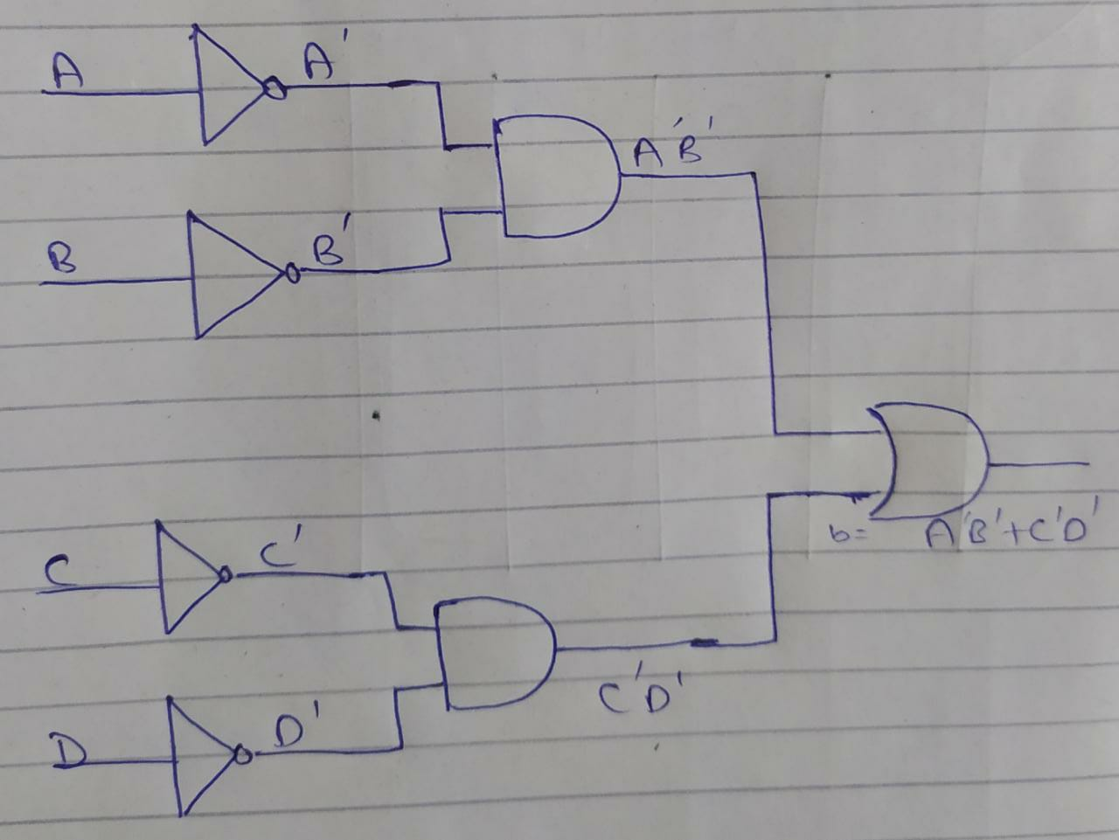

For c:

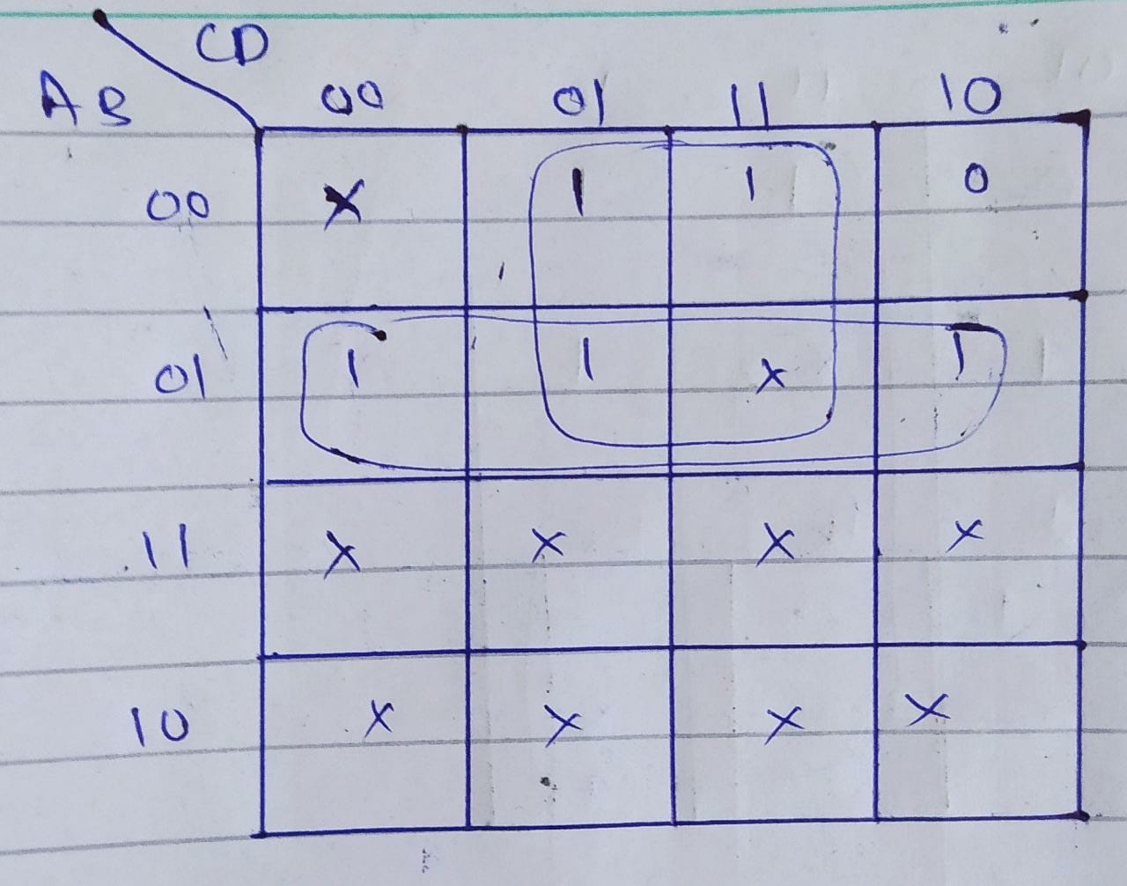

Implementation:

1. m1+m3+m5+m7

=A’D

1. m4+m5+m7+m6

=A’B

So,

c=A’D+A’B

Logic Diagram:

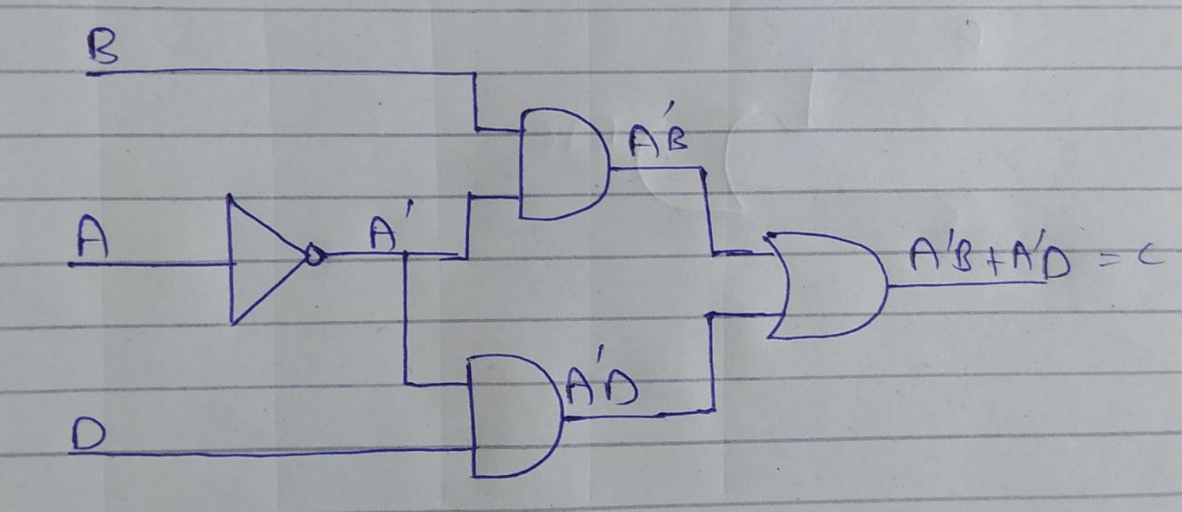

For d:

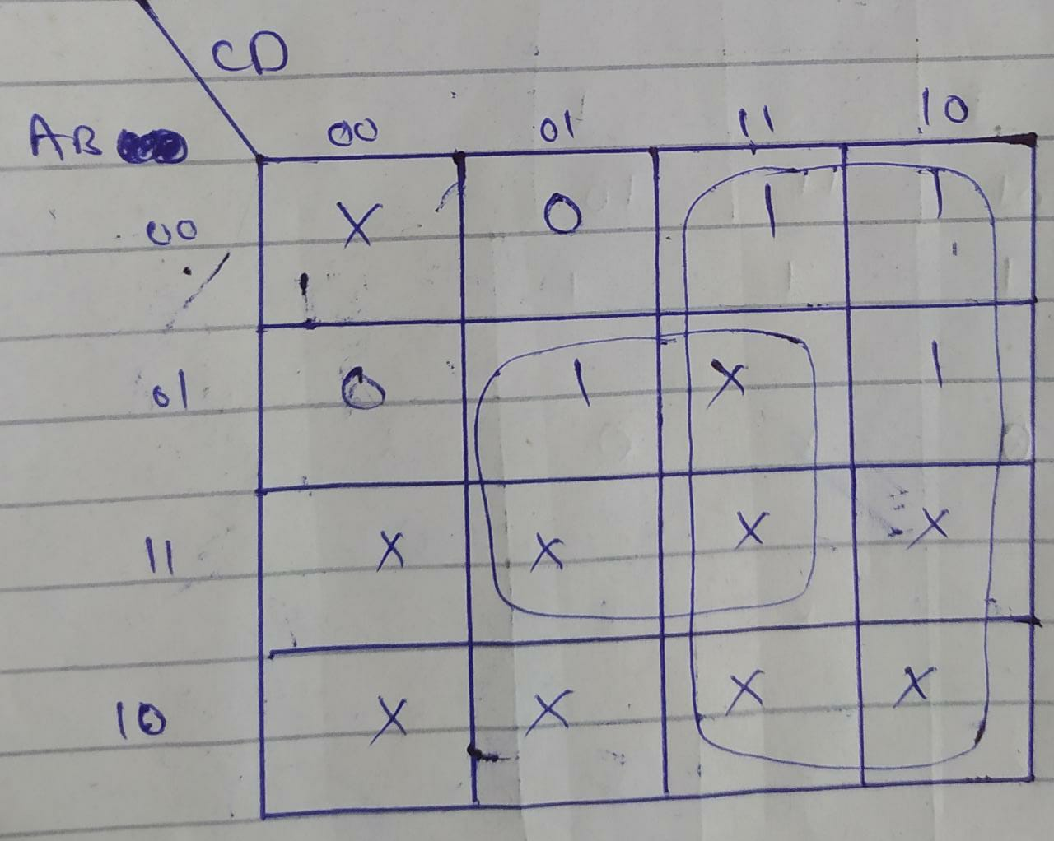

Implementation:

1. m5+m7+m13+m15

=BD

1. m3+m2+m7+m6+m15+m14+m11+m10

=C

So,

d=BD+C

Logic Diagram:

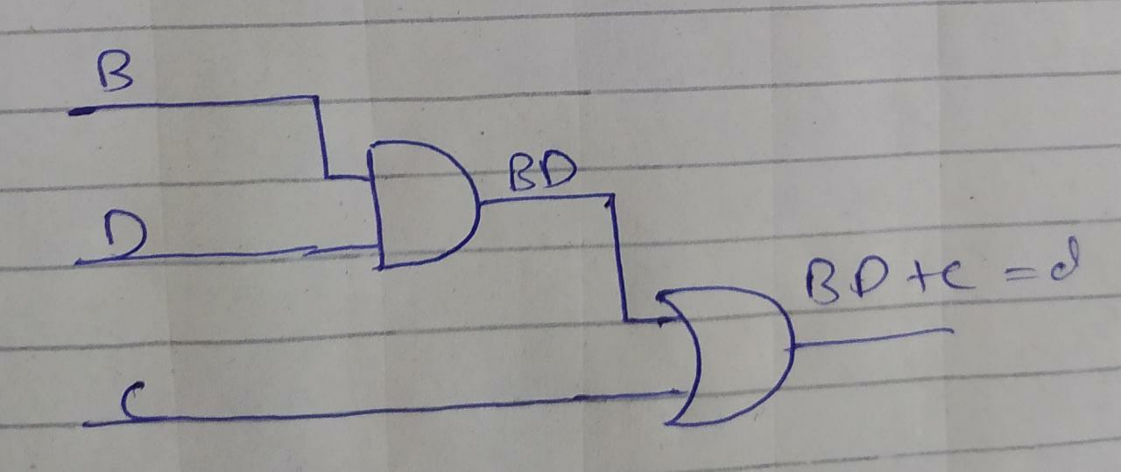

For e:

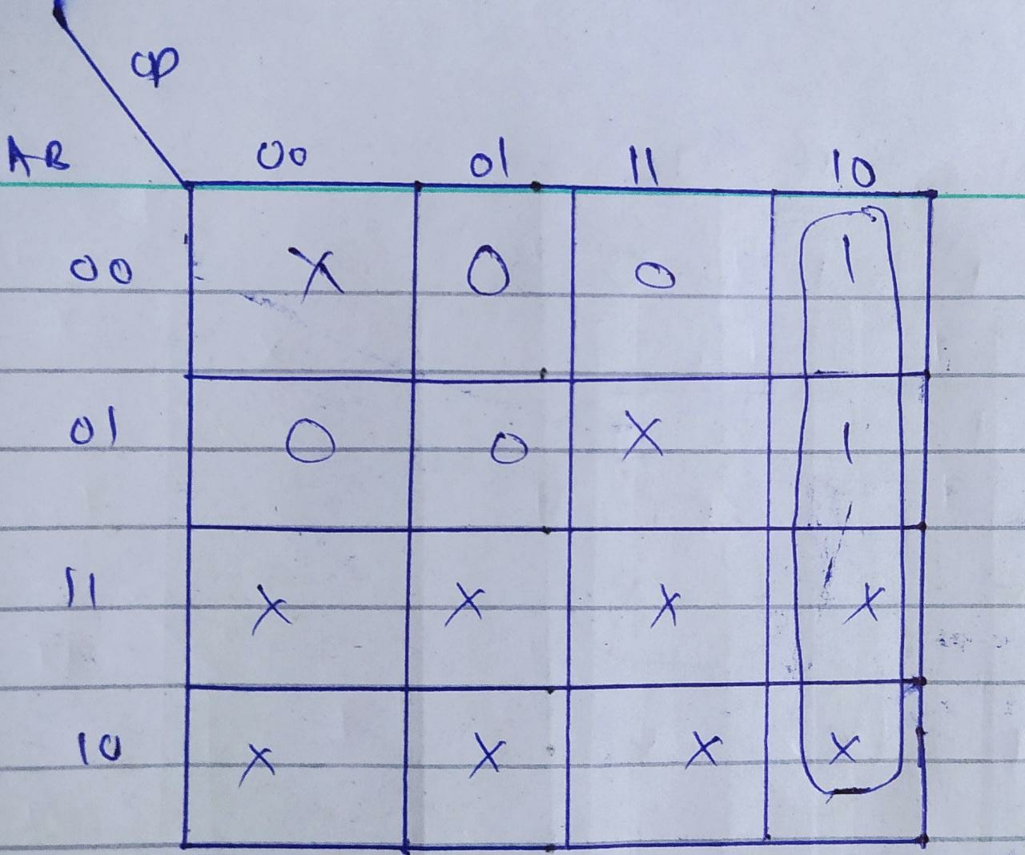

Implementation:

e= CD’

Logic Diagram:

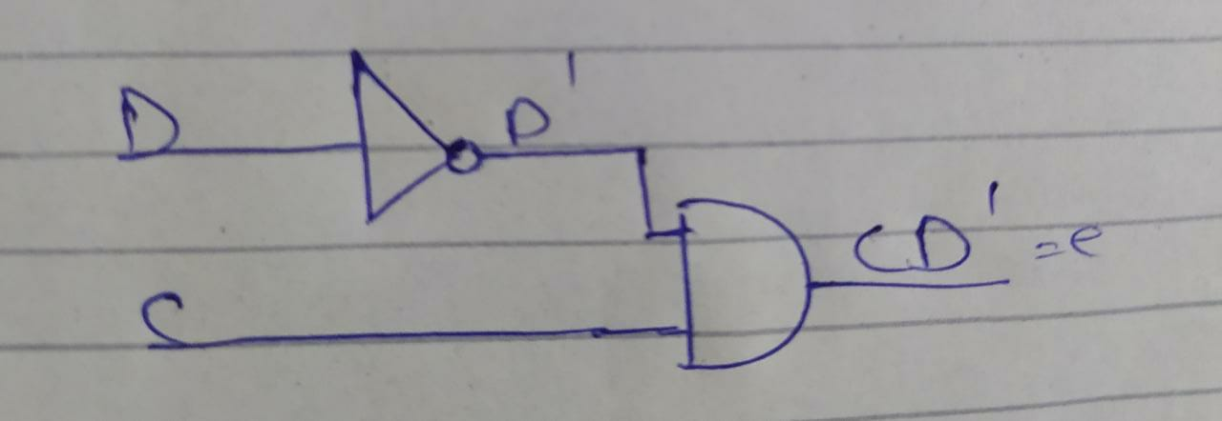

For f:

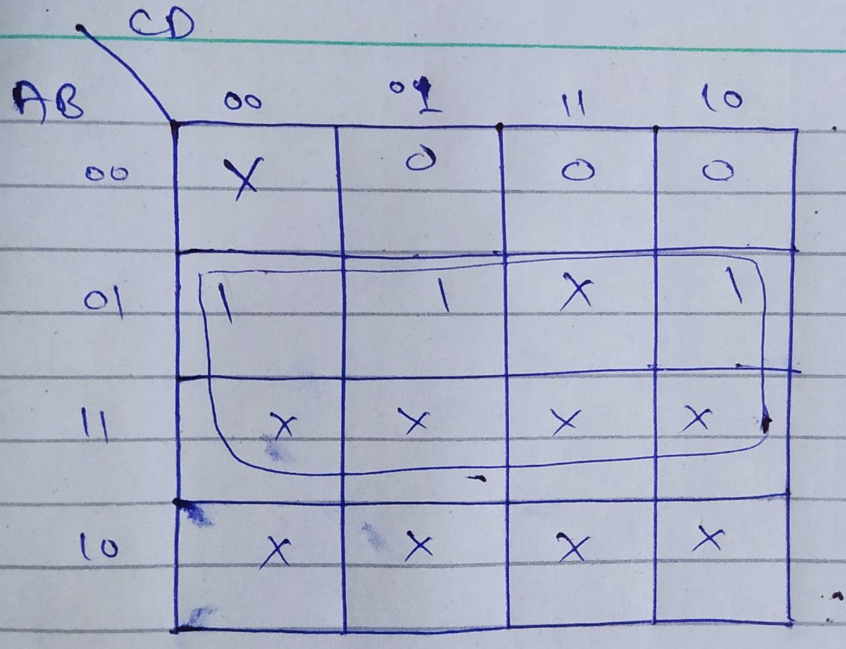

Implementation:

f= B

For g:

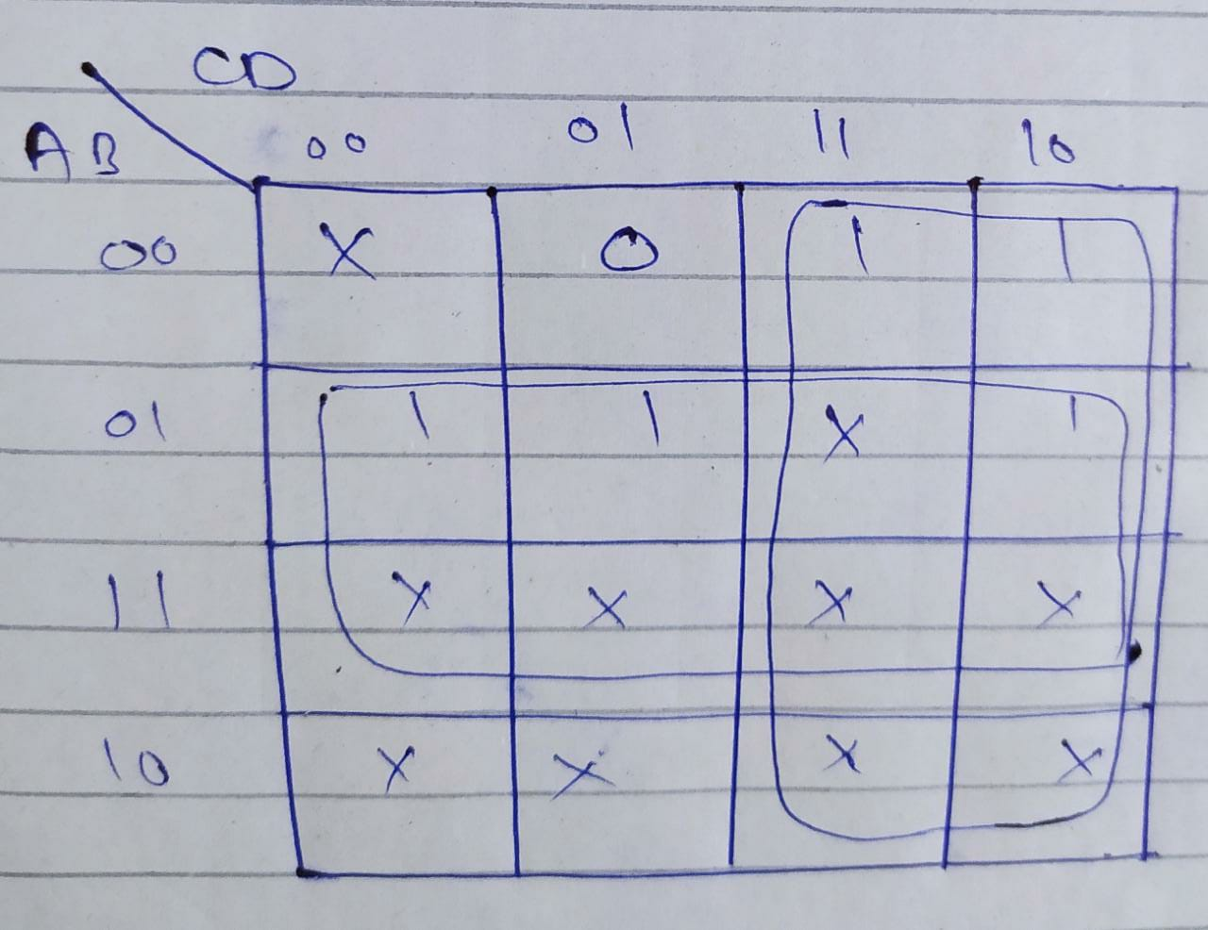  
Implementation:

1. m4+m5+m7+m6+m12+m13+m15+m14

=B

1. m3+m2+m7+m6+m15+m14+m11+m10

=C

So,

g= B+C

Logic Diagram:

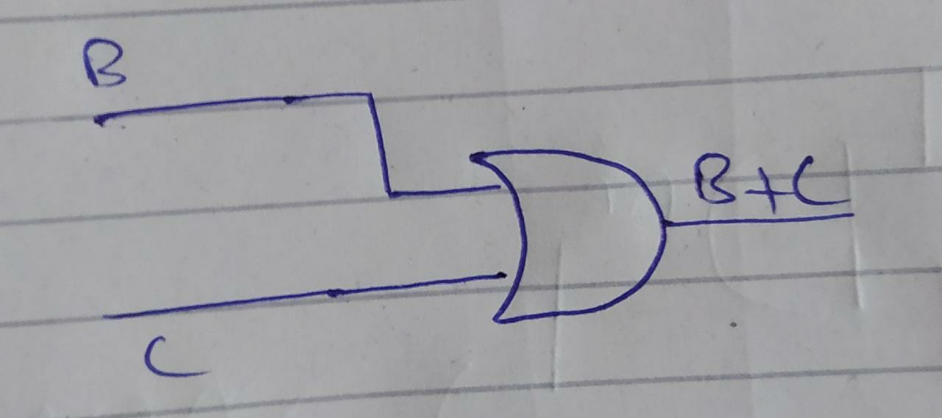

Proteus Simulation of whole Digital Dice Circuit:

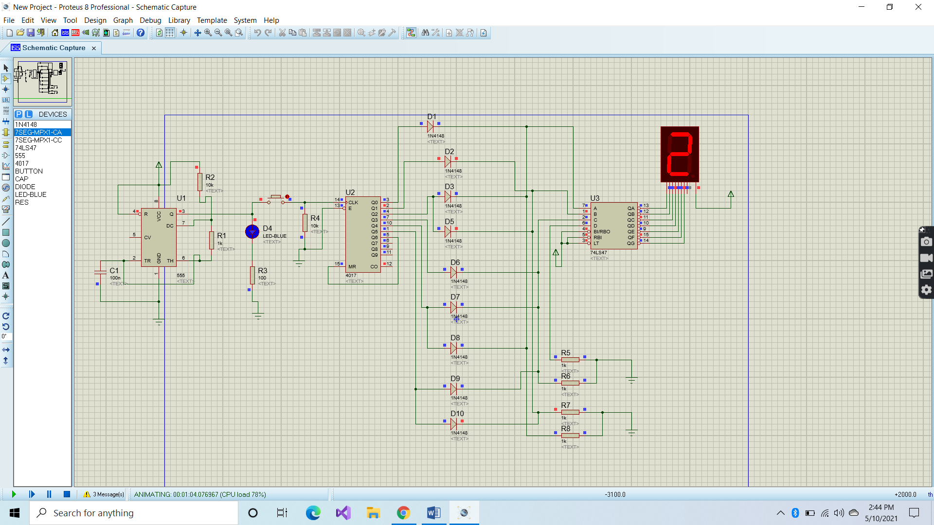

**Details of ICs used:**

1. 7 seg-IC: It consist of 7 LEDs. It is used for displaying numbers from 0 to 9 numbers.
2. 4017-IC: It is a CMOS decade counter that includes a 5-stage Johnson decade counter which is capable to deliver about 10 decoded outputs.
3. 555 Timer IC: It is used in many variants of timer and pulse generation.
4. 74LS47 IC: It is used to drive 7 segment display. We use the 74ls47 IC with common anode 7-segment display.

**Details of Other Components:**

1. Resistors: Resistors are used to reduce current flow in an electric circuit and adjust signal level. In our dice circuit it is used to reduce voltage to a level that is appropriate for specific parts of our circuit.
2. Capacitors: They are used in electronic circuits for blocking direct current while allowing alternating current to pass.
3. Button: We can also call it a switch as it connects and disconnects the conducting path in circuit. In our project, when we press it or connect it from both ends its passes the electrical pulses from 555 timer to 4017 IC.
4. Diode**:** In circuit, it helps the current to flow only in one direction.

**Simulation Issues:**

In the start of Proteus Implementation, we have faced many problems. Like, in 7 segment display, we get many errors. On 7 segment display, we only need 1 to 6 numbers being displayed but we get almost every digit from 1 to 9. But, by working on the circuit and consulting with each of the group member helps us to make a perfect dice circuit.

**Chapter#03:**

**Project Applications/Games:**

* SNAKE LADDER GAME
* LUDO GAME
* LUCK GAME (A type of game in which some prizes are enlisted on following numbers and when you get those number on your dice, you will get that prize.)

**Future Recommendations:**

In future this digital dice will be used in every game in which dice is used. The players who become tired as they frequently uses their hands to throw dice again and again will prefer to use digital dice.